
School of Electronics Engineering (SENSE)
PROJECT BASED LEARNING (J Component) - REPORT
COURSE CODE / NAME | ECM2001–DATA COMMUNICATION NETWORK
PROGRAM / YEAR | B.Tech (ECM)
LAST DATE FOR REPORT SUBMISSION | 4-11-2019
DATE OF SUBMISSION | 4-11-2019
TEAM MEMBERS  DETAILS | REGISTER NO. | NAME
TEAM MEMBERS  DETAILS | 17BLC1007 | AVULA ROHITHA
TEAM MEMBERS  DETAILS | 17BLC1018 | MULAGADA.GEETANJALI
TEAM MEMBERS  DETAILS | 17BLC1024 | KONENI .MADHU SWAPNIKA
TEAM MEMBERS  DETAILS | 17BLC1166 | AARTHI G
J TITLE | NETWORK DESIGN PROPOSAL FOR UNIVERSITY
COURSE HANDLER’S NAME | Prof. T. Jayavignesh |  | REMARKS
COURSE HANDLER’S SIGN |  |  | REMARKS
BONAFIDE CERTIFICATE
Certified that this project report entitled “NETWORK DESIGN PROPOSAL FOR UNIVERSITY” is a bonafide work of AVULA.ROHITHA (17BLC1007), MULAGADA.GEETHANAJLI (17BLC1018), KONENI.MADHU SWAPNIKA (17BLC1024) and AARTHI.G (17BLC1166) who carried out the Project work under my supervision and guidance.

-------------------------------------
Prof. JAYA VIGNESH T
Assistant Professor
School of Electronics Engineering (SENSE),
VIT University, Chennai
Chennai – 600 127.

------------------------------- ------------------------------
AVULA ROHITHA MULAGADA.GEETANJALI
(17BLC1007) (17BLC1018)

------------------------------------- -----------------------------------
KONENI .MADHU SWAPNIKA AARTHI G
(17BLC1024) (17BLC1166)
ABSTRACT
College Network is a set of VLAN that covers the whole campus. The college network through its application interface provide sustain different activities in the college and hence this network is to be designed in advance. Local area network (LAN) is an computer network that interconnect computers within a limited area network such as residence,school,college,laboratories, university campus, office building and soon.Virtual local area network (VLAN) is any broadcast domain that is partitioned and isolated in computer network at data link layer and it provides virtual access to the users. Internet of things is the network of physical devices, home appliances, and other item embedded with the electronics, software sensors, actuators, and connectivities. And which enables this object to connect and exchange the data. College network is the integrated network within the college, which as been designed mainly for share, access and manage different activities of the college campus between its different sections(Branches, Library, Admin block, Principal office, Examination section and so on). The Advanced College Network Design(ACND) his structured using different layers like core layers, distribution layer and access layer, each layer performs the different activities. Cisco currently release new version of packet tracer that include IOE device with classical network device.
KEYWORDS: College Network (CN), Advanced college network design (ACND), Virtual local area network (VLAN)

ACKNOWLEDGEMENT
We wish to express our sincere thanks and deep sense of gratitude to our project guide, Prof. Jaya Vignesh T, Assistant Professor, School of Electronics Engineering , for her consistent encouragement and valuable guidance offered to us in a pleasant manner throughout the course of the project work.
We are extremely grateful to Dr. Sri Devi.V.T, Dean of the School of Electronics Engineering, VIT Chennai, for extending the facilities of the School towards our project and for her unstinting support.
We express our thanks to our Programme Chair, Dr.Thiripurasundhari D and Co-Chair Prof.ReenaMonica.P for their support throughout the course of this project.
We also take this opportunity to thank all the faculty of the School for their support and their wisdom imparted to us throughout the course.
We thank our parents, family, and friends for bearing with us throughout the course of our project and for the opportunity they provided us in undergoing this course in such a prestigious institution.

TABLE OF CONTENTS

S.NO. | DESCRIPTION | PAGE NO.
1. | Abstract | 3
2. | Acknowledgement | 4
3. | Objective and Goals | 6
4. | Introduction | 6
5. | Overview | 7
6. | Benefits of Cisco Packet Tracer | 8
7. | Campus Design Introduction | 8
8. | Campus LAN and Wireless LAN Design | 10
9. | Hierarchal Design Model | 13
10. | LAN Switching | 19
11. | Network Topology | 21
12. | Implementation and Algorithm | 21
13. | Software Required | 29
14. | Software Analysis | 30
15. | Output | 35
16. | Conclusion | 38
17. | Future Work | 38
18. | References | 38

OBJECTIVES AND GOALS
In this proposed system we design an advanced college network design (ACND) for the better use of college network components in the college campus. Thus we use network device like routers, switches, access points, servers, end devices like computers laptops etc. Improving the performance of any network requires a high quality of techniques and services which help to improve the general task of the network. The technical services that have been placed in the university network are a Dynamic Host Configuration Protocol (DHCP) server, a Domain Name System (DNS) server and a cabling system. These tools can increase the performance of the network in general and provide a stable internet service

INTRODUCTION

Today, networks can be constituted by connecting different devices such as computers, phones, printers, mobile devices, etc. wired or wirelessly. We can think of computers or computer that we use at home as part of a network. Because the internet is a network, there are only speed limits and quota. Different networks can share resources or documents with each other over the internet. Generally, it is possible to connect several computers with many cables and create a network through visual interfaces. But this will require both extra physical space and redundant cable redundancy and extra interfaces. Switches have been produced for this purpose. With these switches, we can provide multiple computers to communicate and share with each other.

Simulation technology emerges as a new development in education to be applied to network is such as simulation of network traffic and modeling of network general structure. In the simulation environment to learn how networks work on the computer gives us both time and material advantages. Simulation approach can decrease the increasing costs in education and can raise the reducing realism environment. Network Simulation is a network modeling on a computer and testing how the network will work without being physically installed. The vast majority of network simulator programs are programs used by companies developing network products for training and design purposes. Nowadays, CISCO Company, in the education levels of CCNA, CCNP etc. are using a simulator program developed in place of laboratory applications.

Cisco Packet Tracer is a network simulation tool that enables applications of Cisco branded network devices and network design to be done without using any physical machine or vehicle. Implementing a university network scenario is totally network based. It is often used in big organizations and other institutions to make a secured communication and sharing’s of their documents, files, etc. should also be secured.

As we know that there are many departments in a University. So we desire that these departments should be separate for their good output. Then this project also includes this feature. This type of network avoids the unauthorized access it authenticate the authorized users or hosts. Implementation of logical network topology has been done. All the routers have their password to access them by any user. This network connects the different department of a company or many companies and combines them in a single network. And the implementations of router are very accurate, that they should select the excellent path for the packets and make the communication fast and secure. In the developed scenario adaptive bitrate technology has been used. Adaptive bitrate streaming is a technique used in streaming multimedia over computer networks. A distance vector protocol is implemented in the project and the routers are password protected for security purpose.

In this setup Network Address Translation (NAT) is very essential in which we have translate live Internet Protocol (IP) into local and vice-versa. The fundamental purpose of designing this scenario is to provide security in your network to secure your private data and make a reliable and excellent communication in a WAN connection and reduce the organization dependency on floppy disks etc. Organizations that share data through the use of floppy disks follow a nonefficient or cost-effective method. The issue is that the business by using this method to share data leads to duplication of data which effects the growth of the business.Using this method leads to a major issue i.e. Lack of communication- all details are not possible to be conveyed at the required time. The scope of creating company network scenario is to have a secure WAN network for the communication purpose of an company that eradicate data redundancy from the grass root level which shows smooth functioning of a network.
OVERVIEW
Local area network (LAN) is an computer network that interconnect computers within a limited area network such as residence, school, college, laboratories, university campus, office building and soon. Virtual local area network
(VLAN) is any broadcast domain that is partitioned and isolated in computer network at data link layer and it provides virtual access to the users. Internet of things is the network of physical devices, home appliances, and other item
embedded with the electronics, software sensors, actuators, and connectivities. And which enables this object to connect and exchange the data. College network is the integrated network within the college, which as been designed
mainly for share, access and manage different activities of the college campus between its different sections (Branches, Library, Admin block, Principal office, Examination section and so on). The Advanced College Network Design
(ACND) his structured using different layers like core layers, distribution layer and access layer, each layer performs the different activities
BENEFITS OF CISCO PACKET TRACER
The benefits of the Cisco Packet Tracer program include:
• It provides a comfortable and well-informed environment.
• It provides multi-user, real-time training laboratories.
• It can prepare exams for students and give points according to what they do.
• Network environment is designed, and network devices are configured using virtual equipment
CAMPUS DESIGN INTRODUCTION
There is a tendency to discount the network as just simple plumbing, to think that all you have to consider is the size and the length of the pipes or the speeds and feeds of the links, and to dismiss the rest as unimportant. Just as the plumbing in a large stadium or high rise has to be designed for scale, purpose, redundancy, protection from tampering or denial of operation, and the capacity to handle peak loads, the network requires similar consideration. As users depend on the network to access the majority of the information they need to do their jobs and to transport their voice or video with reliability, the network must be able to provide resilient, intelligent transport. The reliable network design also needs to incorporate versatility in order to address the changing needs of an organization.
Here are some key concepts that you should address when creating a reliable and versatile network design. The network should be:
- Self-healing—Continuously on and available.
- Self-defending—Protecting the organization and its users.
- Self-optimizing—Adapting to changing needs, beyond the limits of basic
standards.
- Self-aware—Driving change through insight into network activity.

As you look at a network design, consider the networking trends and future needs of an organization. The network must be ready to appropriately scale over time in order to meet the demands of the organization it is supporting.
- Because demands on wireless access points (APs) with the latest 802.11ac Wave 2 technology exceed 1 Gbps, and the IEEE has ratified the 802.3bz standard that defines 2.5 Gbps and 5 Gbps Ethernet, you should deploy a network that is ready to support the demand without requiring an upgrade of the existing copper Ethernet wiring plant. You accommodate these latest demands by deploying network platforms including Cisco® Catalyst Multigigabit technology.
- As you deploy new devices with higher power requirements, such as lighting, surveillance cameras, virtual desktop terminals, remote access switches, and APs, your design should have the ability to support power over Ethernet with 60W per port, offered with Cisco Universal Power Over Ethernet, and the access layer should also provide PoE perpetual power during switch upgrade and reboot events. The Cisco Catalyst 9000 Series access layer switches are perpetual PoE-capable and ready for 100W per port, as that technology becomes available.
- Compliance issues drive a choice of platforms required when you support standards certifications and MACsec. For those cases, you should also be prepared to make analytic data available, using technologies such as Net Flow.
- The Internet of Things and Internet of Everything impacts today’s network design. Your network should support Trust Sec and other segmentation and virtualization technologies in order to enable the scale and expanded uses and policies for the network driven by these trends.
- Bandwidth needs are doubling potentially multiple times over the lifetime of a network so that the network deployed today needs to be prepared to aggregate using 10 Gbps Ethernet to 40 Gbps to 100 Gbps capacities over time.
- The network platforms deployed today should offer the best longevity into the future, versus selecting the equipment that only meets the limits of today’s needs.

- To reduce operational complexity, you can use a centralized controller with open APIs, allowing for very fast, lower-risk deployment of network devices and services through UI and existing orchestration systems—Cisco DNA Center automates this network device configuration and management to achieve your organization’s intent.
Cisco Digital Network Architecture (Cisco DNA) provides a roadmap to digitization and a path to realize immediate benefits of network automation, assurance, and security. The campus local area network (LAN) is the network that supports devices people use within a location to connect to information. The use of the word campus does not imply any particular geographic size—the campus LAN can range in size from a single switch at a small remote site up to a large multi-building infrastructure, supporting classrooms, carpeted office space, and similar places where people use their devices for their daily activities. The campus design incorporates both wired LAN and wireless LAN connectivity for a complete network access solution.

CAMPUS LAN AND WIRELESS LAN DESIGN
- Designing a LAN for the campus use case is not a one-design-fits-all proposition. The scale of campus LAN can be as simple as a single switch and wireless AP at a small remote site or a large, distributed, multi-building complex with high-density wired port and wireless requirements. The deployment may require very high availability for the services offered by the network, with a low tolerance for risk, or there may be tolerance for fix-on-failure approach with extended service outages for a limited number of users considered acceptable. Platform choices for these deployments are often driven by needs for network capacity, the device and network capabilities offered, and also the need to meet any compliance requirements that are important to the organization.
- You impose most of the campus wired LAN design complexity when aggregating groups of access switches by interconnecting the access layers to the distribution layers. If devices connecting to the access layer have a requirement to communicate with a Layer 2 logical adjacency and those connections cover multiple physical wiring closets connected to a distribution layer, then it is possible to adapt the traditional multilayer campus design to address the Layer 2 adjacency needs. However, the traditional designs drive more complex configurations with additional protocols that must be kept consistent across multiple devices.
- To improve the design, there are preferred alternatives that make the deployment easier to manage and less prone to mistakes, while enhancing overall network performance. Such alternatives include the simplified distribution layer option using either a switch stack or a virtual switching system (VSS) or a Stack Wise Virtual system, which makes deployment and troubleshooting much easier for support staff.
- A design alternative is available for organizations that either don’t have the need to extend Layer 2 connectivity across an access-to-aggregation boundary or have other means of implementing this functionality, such as when using Campus Fabric technology—an integral part of Cisco Software-Defined Access (SD-Access). The alternative is to extend Layer 3 connectivity to the access layer. The implementation of a well-designed Layer 3 access network ensures consistent, configuration, performance, scalability, and high availability of the network versus the traditional multilayer campus design.
- The motivation for the recommended design choices is not that they are the only options available but that the recommendations highlight preferred choices given the scope of the requirements. Even though the traditional multilayer campus design previously mentioned is a widely deployed, valid design choice, the design is not one that is typically recommended in light of better alternatives that are currently available.
- When you integrate the wireless components of the campus design with the wired components, the design can often be treated as an overlay that is dependent upon the services provided by the underlying campus infrastructure. This is especially evident for larger networks, because increasing capacity with dedicated devices becomes a requirement. Smaller networks, such as those at small remote sites, offer opportunities for simplification and optimization that are also reflected in the design choices shown below.
- The primary design options are grouped by scale, and then appropriate selections are based on the capabilities desired. The selection from the spectrum of capabilities is based on the needs of a specific deployment.
- As you go through the design guidance, you should keep the following capabilities in mind when considering which of the previously mentioned categories are most important for your network deployment.
SELF-HEALING
To keep your network continuously on and available, pay attention to the high availability concepts for both a resilient wired switching infrastructure and also for the wireless infrastructure that integrates with it. Resiliency is not only based on the component redundancy and how interconnections are made in the modular campus design but also what capabilities can enhance that physical resiliency.
For example, can you detect and react to RF interference and mitigate its impact in your wireless access network? Can equipment be removed from the network and connectivity for people to information be maintained without interruption?
Resiliency is enhanced by avoiding network impacts to begin with, as described with the next set of capabilities.
SELF-DEFENDING
To protect the organization and its users from disruptions to their productivity, avoiding the disruptions before they begin is the surest way to keep network services available. There are a range of capabilities to help with this task. For the wired infrastructure, the basic set of Catalyst Infrastructure Security Features include many capabilities to keep intentional and unintentional disruptions from impacting the network, which can be augmented all the way to using enhanced policies through TrustSec segmentation. The wireless network can also defend itself through the implementation of rogue device detection, among other features.
Basic defense mechanisms should be a part of all networks, with the extent of the capabilities chosen based on deployment needs. Once the network can defend itself appropriately, the next step is to optimize itself, as described with the next group of capabilities.
SELF-OPTIMIZING
To adapt to changing needs, beyond the limits of just the basic published standards, is a key requirement for more advanced networks. Basic standards don’t address a specific organization’s intent for how devices should behave on their network. Mobile phones may have personal uses, but need to have priority access to a limited shared RF resource for the applications that are important to a function of an organization. When choosing from the spectrum of capabilities available, networks with mission critical capabilities can be created that are able to address these needs.
SELF-AWARE
To drive change through insight into network activity, the best networks can report insight into traffic that they transport and how it relates to an organization’s mission. Application visibility from both wired and wireless devices using NetFlow, Network Based Application Recognition (NBAR) and other capabilities, can give insight into how users interact with applications and other users on the network. Besides just reporting information, capabilities such as wireless hyperlocation and analytics enable organizations to provide location-specific services to the users. So in essence the network can provide information for how the users are using the network while at the same time provide or advertise services based on a user’s access to the network.
- The capabilities highlighted in these categories are a small sample of the capabilities that are increasingly available as you make your design choices across the spectrum from the foundation to the mission-critical design options, as shown below, for each campus network within the appropriate topology sizing choice.
CAMPUS WIRED LAN DESIGN
The LAN is the networking infrastructure that provides access to network communication services and resources for end users and devices spread over a single floor or building. You create a campus network by interconnecting a group of LANs that are spread over a small geographic area. Campus network design concepts are inclusive small networks that use a single LAN switch, up to very large networks with thousands of connections.
The campus wired LAN enables communications between devices in a building or group of buildings, as well as interconnection to the WAN and Internet edge at the network core.
Specifically, this design provides a network foundation and services that enable:
- Tiered LAN connectivity.
- Wired network access for employees.
- IP Multicast for efficient data distribution.
- Wired infrastructure ready for multimedia services.

HIERARCHICAL DESIGN MODEL
The campus wired LAN uses a hierarchical design model to break the design up into modular groups or layers. Breaking the design up into layers allows each layer to implement specific functions, which simplifies the network design and therefore the deployment and management of the network.
Modularity in network design allows you to create design elements that can be replicated throughout the network. Replication provides an easy way to scale the network as well as a consistent deployment method.
In flat or meshed network architectures, changes tend to affect a large number of systems. Hierarchical design helps constrain operational changes to a subset of the network, which makes it easy to manage as well as improve resiliency. Modular structuring of the network into small, easy-to-understand elements also facilitates resiliency via improved fault isolation.
A hierarchical LAN design includes the following three layers:
- Access layer—Provides endpoints and users direct access to the network
- Distribution layer—Aggregates access layers and provides connectivity to services
- Core layer—Provides connectivity between distribution layers for large LAN environments
Each layer—access, distribution, and core—provides different functionality and capability to the network. Depending on the characteristics of the deployment site, you might need one, two, or all three of the layers. For example, a site that occupies a single building might only require the access and distribution layers, while a campus of multiple buildings will most likely require all three layers.
- Regardless of how many layers are implemented at a location, the modularity of this design ensures that each layer will provide the same services, and in this architecture, will use the same design methods.
ACCESS LAYER
- The access layer is where user-controlled devices, user-accessible devices, and other end-point devices are connected to the network. The access layer provides both wired and wireless connectivity and contains features and services that ensure security and resiliency for the entire network.
- Device connectivity—The access layer provides high-bandwidth device connectivity. To help make the network a transparent part of an end-user’s day-to-day job, the access layer must support bursts of high-bandwidth traffic when users perform routine tasks, such as sending large emails or opening a file from an internal web page. Because many types of end-user devices connect at the access layer—personal computers, IP phones, wireless APs, and IP video surveillance cameras—the access layer can support many logical networks, delivering benefits for performance, management, and security.
- Resiliency and security services—The access-layer design must ensure that the network is available for all users who need it, whenever they need it. As the connection point between the network and client devices, the access layer must help protect the network from human error and from malicious attacks. This protection includes ensuring that users have access only to authorized services, preventing end-user devices from taking over the role of other devices on the network, and, when possible, verifying that each end-user device is allowed on the network.
- Advanced technology capabilities—The access layer provides a set of network services that support advanced technologies, such as voice and video. The access layer must provide specialized access for devices using advanced technologies, to ensure that traffic from these devices is not impaired by traffic from other devices and also to ensure efficient delivery of traffic that is needed by many devices in the network.
Access-Layer Platforms
The preferred options for the campus wired LAN include the following Cisco switches as access-layer platforms:
- Cisco Catalyst 9300 Series Switches
- Cisco Catalyst 9400 Series Switches
- Cisco Catalyst 2960-X and 2960-XR Series Switches

DISTRIBUTION LAYER
The distribution layer supports many important services. In a network where connectivity needs to traverse the LAN end-to-end, whether between different access layer devices or from an access layer device to the WAN, the distribution layer facilitates this connectivity.
- Scalability—At any site with more than two or three access-layer devices, it is impractical to interconnect all access switches. The distribution layer serves as an aggregation point for multiple access-layer switches. The distribution layer can lower operating costs by making the network more efficient, by requiring less memory, by creating fault domains that compartmentalize failures or network changes, and by processing resources for devices elsewhere in the network. The distribution layer also increases network availability by containing failures to smaller domains.
- Reduce complexity and increase resiliency—The campus wired LAN has the option to use a simplified distribution layer, in which a distribution-layer node consists of a single logical entity that can be implemented using a pair of physically separate switches operating as one device or using a physical stack of switches operating as one device. Resiliency is provided by physically redundant components like power supplies, supervisors, and modules, as well as stateful switchover to redundant logical control planes. This approach reduces complexity of configuring and operating the distribution layer because fewer protocols are required. Little or no tuning is needed to provide near-second or sub-second convergence around failures or disruptions.
TWO-TIER DESIGN
- The distribution layer provides connectivity to network-based services, to the WAN, and to the Internet edge. Network-based services can include and are not limited to Wide Area Application Services (WAAS) and WLAN controllers. Depending on the size of the LAN, these services and the interconnection to the WAN and Internet edge may reside on a distribution layer switch that also aggregates the LAN access-layer connectivity. This is also referred to as a collapsed core design because the distribution serves as the Layer 3 aggregation layer for all devices.
THREE-TIER DESIGN
- Larger LAN designs require a dedicated distribution layer for network-based services versus sharing connectivity with access layer devices. As the density of WAN routers, WAAS controllers, Internet edge devices, and WLAN controllers grows, the ability to connect to a single distribution layer switch becomes hard to manage. When connecting at least three distributions together, using a core layer for distribution connectivity should be a consideration.
There are a number of factors that drive LAN design with multiple distribution layer modules:
- The number of ports and port bandwidth that the distribution layer platform can provide affects network performance and throughput.
- Network resilience is a factor when all LAN and network-based services rely on a single platform, regardless of that platform’s design, it can present a single point of failure or an unacceptably large failure domain.
- Change control and frequency affects resilience. When all LAN, WAN, and other network services are consolidated on a single distribution layer, operational or configuration errors can affect all network operation.
- Geographic dispersion of the LAN access switches across many buildings in a larger campus facility would require more fiber optic interconnects back to a single collapsed core.
Like the access layer, the distribution layer also provides quality of service (QoS) for application flows to guarantee critical applications and multimedia applications perform as designed.
CORE LAYER
In a large LAN environment, there often arises a need to have multiple distribution layer switches. One reason for this is that when access layer switches are located in multiple geographically dispersed buildings, you can save potentially costly fiber-optic runs between buildings by locating a distribution layer switch in each of those buildings. As networks grow beyond three distribution layers in a single location, organizations should use a core layer to optimize the design.
- Another reason to use multiple distribution layer switches is when the number of access layer switches connecting to a single distribution layer exceeds the performance goals of the network designer. In a modular and scalable design, you can collocate distribution layers for data center, WAN connectivity, or Internet edge services.
CAMPUS WIRED NETWORK DESIGN OPTIONS
When you scale from a single switch in a campus LAN up to a full three-tier campus network, the reliability of the network is increasingly important, because network downtime likely affects a greater user population with a larger workplace and economic significance. To mitigate the concerns about unavailability of network resources, campus designs include additional resiliency options, such as redundant links, switches, and switch components. In traditional multilayer campus designs, the added resiliency comes at a cost of configuration complexity, with most of the complexity introduced from the interaction of the access and aggregation layers of the campus LAN.
- The primary function of the distribution layer is to aggregate access layer switches in a given building or campus. The distribution layer provides a boundary between the Layer 2 domain of the access layer and the Layer 3 domain that provides a path to the rest of the network. This boundary provides two key functions for the LAN. On the Layer 2 side, the distribution layer creates a boundary for spanning tree protocol (STP), limiting propagation of Layer 2 faults. On the Layer 3 side, the distribution layer provides a logical point to summarize IP routing information when it enters the network. The summarization reduces IP route tables for easier troubleshooting and reduces protocol overhead for faster recovery from failures.
TRADITIONAL MULTILAYER CAMPUS DISTRIBUTION LAYER DESIGN
Traditional LAN designs use a multi-tier approach with Layer 2 from the access layer to the distribution layer, where the Layer 3 boundary exists. The connectivity from the access layer to the distribution layer can result in either a loop-free or looped design.
In the traditional network design, the distribution layer has two standalone switches for resiliency. It is recommended that you restrict a Layer 2 virtual LAN (VLAN) to a single wiring closet or access uplink pair in order to reduce or eliminate topology loops that STP must block and that are a common point of failure in LANs. Restricting a VLAN to a single switch provides a loop-free design, but it does limit network flexibility.
- To create a resilient IP gateway for VLANs in the traditional design, you must use first-hop redundancy protocols, which provide hosts with a consistent MAC address and gateway IP for a VLAN. Hot standby routing protocol (HSRP) and virtual router redundancy protocol (VRRP) are the most common gateway redundancy protocols, but they only allow hosts to send data out one of the access uplinks to the distribution layer and require additional configuration for each aggregation switch in order to allow you to distribute VLANs across uplinks. Gateway load-balancing protocol (GLBP) does provide greater uplink utilization for traffic exiting the access layer by balancing load from hosts across multiple uplinks, but you can only use it in a non-looped topology.
All of these redundancy protocols require that you fine-tune the default timer settings in order to allow for sub-second network convergence, which can impact switch CPU resources.
- Some organizations require the same Layer 2 VLAN be extended to multiple access layer closets to accommodate an application or service. The looped design causes spanning tree to block links, which reduces the bandwidth from the rest of the network and can cause slower network convergence. The inefficiencies and the increased potential for misconfiguration drive network engineers to look for more appealing alternatives.
ROUTED ACCESS LAYER TO DISTRIBUTION DESIGN
In another approach to access and distribution layer design, you can use Layer 3 all the way to the access layer. The benefits of this design are that you eliminate spanning tree loops and reduce protocols because the IP gateway is now the access switch. Because there are no spanning-tree blocking links, you can use both uplinks to the access layer and increase effective bandwidth available to the users.
- The challenge with the routed access layer design is that the Layer 2 domains are confined to a single access closet, which limits flexibility for applications that require Layer 2 connectivity that extends across multiple access closets.
SIMPLIFIED DISTRIBUTION LAYER DESIGN
- An alternative that can handle Layer 2 access requirements and avoid the complexity of the traditional multilayer campus is called a simplified distribution layer design. The design uses multiple physical switches that act as a single logical switch, such as switch stack or a VSS, or the less preferred single, highly-redundant physical switch. One advantage of this design is that spanning tree dependence is minimized, and all uplinks from the access layer to the distribution are active and passing traffic. Even in the distributed VLAN design, you eliminate spanning tree blocked links because of looped topologies. You reduce dependence on spanning tree by using EtherChannel to the access layer with dual-homed uplinks. This is a key characteristic of this design, and you can load-balance up to eight links if needed for additional bandwidth. At the same time, multiple links in an EtherChannel have better performance characteristics versus single independent links.
There are several other advantages to the simplified distribution layer design. You no longer need IP gateway redundancy protocols such as HSRP, VRRP, and GLBP, because the default IP gateway is now on a single logical interface and resiliency is provided by the distribution layer switch or switches. Also, the network will converge faster now that it is not depending on spanning tree to unblock links when a failure occurs, because EtherChannel provides fast sub-second failover between links in an uplink bundle.
The topology of the network from the distribution layer to the access layer is logically a hub-and-spoke topology, which reduces complexity of design and troubleshooting. The hub-and-spoke topology design provides a more efficient operation for IP Multicast in the distribution layer because there is now a single logical designated router to forward IP Multicast packets to a given VLAN in the access layer.
- Finally, by using the single logical distribution layer design, there are fewer boxes to manage, which reduces the amount of time spent on ongoing provisioning and maintenance.

LAN SWITCHING

Switches are a fundamental part of most networks. They let multiple users communicate directly with each other. As such, they offer the potential for collision-free, high-speed networking. In essence, switches create a system of
simultaneous, parallel, point-to-point connections between pairs of devices. Benefits of LAN switches:

Increased network scalability:-
The network can expand easily as the business grows.
Improved bandwidth performance for each network user:-
This is important in environments where users operate multimedia applications or conduct frequent client/server database interactions.
Multiple simultaneous connections:-
Many simultaneous data transfers can take place between pairs of devices
connected to switch ports. This is not possible with hub-based networks.
Reduced congestion and information transmission delay:-
This translates to more efficient business application access.Remember that network segmentation is used to minimize the number of users contending for LAN bandwidth on each segment (switch port).
No single point of failure:-
With proper network design, there are fewer chances for network failure.
Improved manageability and security through the use of
virtual LANs (VLANs):-
VLANs group individual users into logical workgroups with common interests or business functions. Data broadcasts are restricted to designated members of the group (also called the broadcast domain). This functionality gives companies the flexibility to move employees around physically yet still maintain their functional ties via the VLAN without network reconfiguration. VLANs are discussed in more depth later in this chapter.A small-medium business can choose from a variety of switch types. The most popular options are the following:
Layer 2 switches:-
Also called desktop or workgroup
switches.
Layer 3 switches:-
Also called routing switches or multilayer
switches.

VLAN (Virtual LAN)

VLAN provides Virtual Segmentation of Broadcast Domain in the network. The devices, which are member of same Vlan, are able to communicate with each other. The devices of different Vlan may communicate with each other with routing.So that different Vlan devices will use different network addresses. A virtual LAN (VLAN) is any broadcast domain that is partitioned and isolated in a computer network at the data link layer(OSI layer 2).LAN is the abbreviation for local area network and in this context virtual refers to a physical object recreated and altered by additional logic.Vlan provides following adavantages:

Security :
Groups that have sensitive data are separated from the rest of the network,decreasing the chances of confidential information branches.
Cost reduction :
Cost savings result from less need for expensive upgrades and more efficient use of existing bandwidth and uplinks.Some of the savings are reduced by administrative costs needed for university to configure VLANs into switches.
Higher performance :
Dividing flat layer 2 networks into multiple logical workgroups(broadcast domains) reduces overall network utilization and boosts performance.
Broadcast storm mitigation:
Dividing a network into smaller logical networks results in lower susceptibility to broadcast storms.
Simpler project or application management:
VLANs bring together all required players in a way that makes managing a project or working with a specialized application easier.
Improved IT staff efficiency:
Moves,adds, and changes are easier and less expensive to perform.Network administrators time is freed up for proactive network management.

NETWORK TOPOLOGY
Network topology is the arrangement of the various elements(links, nodes, etc.) of a communication network.Network topology is the topological structure of a network and may be depicted physically or logically. Physical topology is the placement of the various components of a network,including device location and cable installation, while logical topology illustrates how data flows within a network.Distances between nodes, physical interconnections, transmission rates, or signal types may differ between two networks, yet their topologies may be identical.An example is a local area network (LAN). Any given node in the LAN has one or more physical links to other devices in the network; graphically mapping these links results in a geometric shape that can be used to describe the physical topology of the network. Conversely, mapping the data flow between the components determines the logical topology of the network.
IMPLEMENTATION AND ALGORITHM
RIP:
Routing Information Protocol (RIP) is a dynamic routing protocol which uses hop count as a routing metric to find the best path between the source and the destination network. It is a distance vector routing protocol which has AD value 120 and works on the application layer of OSI model. RIP uses port number 520.
Features of RIP :
1. Updates of the network are exchanged periodically.
2. Updates (routing information) are always broadcast.
3. Full routing tables are sent in updates.
4. Routers always trust on routing information received from neighbor routers. This is also known as Routing on rumours.
RIP versions :
There are three vesions of routing information protocol – RIP Version1, RIP Version2 and RIPng.

RIP V1 | RIP V2 | RIPNG
Sends update as broadcast | Sends update as multicast | Sends update as multicast
Broadcast at 255.255.255.255 | Multicast at 224.0.0.9 | Multicast at FF02::9 (RIPng can only run on IPv6 networks)
Doesn’t support authentication of update messages | Supports authentication of RIPv2 update messages | –
Classful routing protocol | Classless protocol, supports classful | Classless updates are sent

DHCP
DHCP (Dynamic Host Configuration Protocol) is a network management protocol used to dynamically assign an Internet Protocol (IP) address to any device, or node, on a network so they can communicate using IP. DHCP automates and centrally manages these configurations rather than requiring network administrators to manually assign IP addresses to all network devices. DHCP can be implemented on small local networks as well as large enterprise networks.
DHCP will assign new IP addresses in each location when devices are moved from place to place, which means network administrators do not have to manually initially configure each device with a valid IP address or reconfigure the device with a new IP address if it moves to a new location on the network. Versions of DHCP are available for use in Internet Protocol version 4 (IPv4) and Internet Protocol version 6 (IPv6). IPv6 became an industry standard in 2017 -- nearly 20 years after its specifications were first published. While the adoption rate of IPv6 was slow, by July 2019 more than 29 percent of Google users were making inquiries using IPv6.

How DHCP works
DHCP runs at the application layer of the Transmission Control Protocol/IP (TCP/IP) protocol stack to dynamically assign IP addresses to DHCP clients and to allocate TCP/IP configuration information to DHCP clients. This includes subnet mask information, default gateway IP addresses and domain name system (DNS) addresses.
DHCP is a client-server protocol in which servers manage a pool of unique IP addresses, as well as information about client configuration parameters, and assign addresses out of those address pools. DHCP-enabled clients send a request to the DHCP server whenever they connect to a network.
Clients configured with DHCP broadcast a request to the DHCP server and request network configuration information for the local network to which they're attached. A client typically broadcasts a query for this information immediately after booting up. The DHCP server responds to the client request by providing IP configuration information previously specified by a network administrator. This includes a specific IP address as well as for the time period, also called a lease, for which the allocation is valid. When refreshing an assignment, a DHCP client requests the same parameters, but the DHCP server may assign a new IP address based on policies set by administrators.
A DHCP server manages a record of all the IP addresses it allocates to network nodes. If a node is relocated in the network, the server identifies it using its Media Access Control (MAC) address, which prevents accidentally configuring multiple devices with the same IP address.
DHCP is not a routable protocol, nor is it a secure one. DHCP is limited to a specific local area network (LAN), which means a single DHCP server per LAN is adequate, or two servers for use in case of a failover. Larger networks may have a wide area network (WAN) containing multiple individual locations. Depending on the connections between these points and the number of clients in each location, multiple DHCP servers can be set up to handle the distribution of addresses. If network administrators want a DHCP server to provide addressing to multiple subnets on a given network, they must configure DHCP relay services located on interconnecting routers that DHCP requests have to cross. These agents relay messages between DHCP clients and servers located on different subnets.
DHCP lacks any built-in mechanism that would allow clients and servers to authenticate each other. Both are vulnerable to deception (one computer pretending to be another) and to attack, where rogue clients can exhaust a DHCP server's IP address pool.
ICMP
Since IP does not have a inbuilt mechanism for sending error and control messages. It depends on Internet Control Message Protocol(ICMP) to provide an error control. It is used for reporting errors and management queries. It is a supporting protocol and used by networks devices like routers for sending the error messages and operations information. E.g. the requested service is not available or that a host or router could not be reached.

Source quench message :
Source quench message is request to decrease traffic rate for messages sending to the host(destination). Or we can say, when receiving host detects that rate of sending packets (traffic rate) to it is too fast it sends the source quench message to the source to slow the pace down so that no packet can be lost.
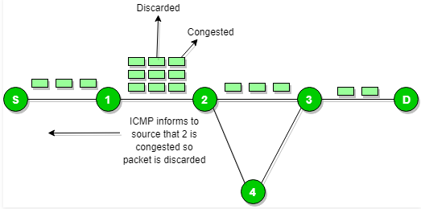
ICMP will take source IP from the discarded packet and informs to source by sending source quench message.
Then source will reduce the speed of transmission so that router will free for congestion.
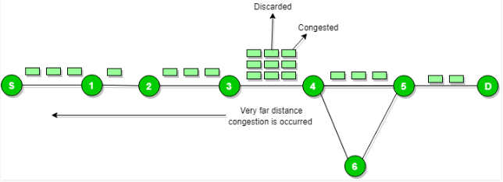
When the congestion router is far away from the source the ICMP will send hop by hop source quench message so that every router will reduce the speed of transmission.

Parameter problem :
Whenever packets come to the router then calculated header checksum should be equal to recieved header checksum then only packet is accepted by the router.
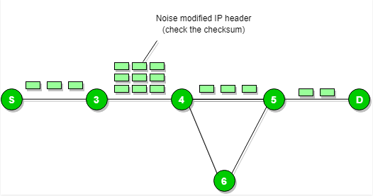
If there is mismatch packet will be dropped by the router.
ICMP will take the source IP from the discarded packet and informs to source by sending parameter problem message.

Time exceeded message :
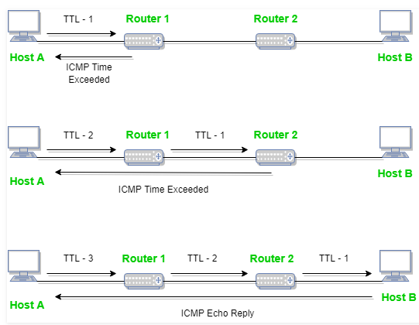
When some fragments are lost in a network then the holding fragment by the router will be droped then ICMP will take source IP from discarded packet and informs to the source, of discarded datagram due to time to live field reaches to zero, by sending time exceeded message.
DNS
The Domain Network System (DNS) protocol helps Internet users and network devices discover websites using human-readable hostnames, instead of numeric IP addresses.
The DNS process, simplified, works as follows:
- A browser, application or device called the DNS client, issues a DNS request or DNS address lookup, providing a hostname such as “example.com”.
- The request is received by a DNS resolver, which is responsible for finding the correct IP address for that hostname. The DNS resolver looks for a DNS name server that holds the IP address for the hostname in the DNS request.
- The resolver starts from the Internet’s root DNS server, moving down the hierarchy to Top Level Domain (TLD) DNS servers (“.com” in this case), down to the name server responsible for the specific domain “example.com”.
- When the resolver reaches the authoritative DNS name server for “example.com”, it receives the IP address and other relevant details, and returns it to the DNS client. The DNS request is now resolved.
- The DNS client device can connect to the server directly using the correct IP address.

The Domain Namespace
The DNS namespace governs public hostnames used on the Internet. The namespace is a tree structure, with each node in the tree having a textual label and zero or more DNS resource records (RR) describing the domain.
The domain name consists of the label, together with the label of its parent nodes, separated by a dot (as in “example.com”). The domain namespace is divided into zones, and each zone is delegated to a specific legal entity for administration and management.

Domain Name Syntax and Format
A domain name consists of one or more parts called labels, which are separated by dots. A label may contain up to 63 characters. The label at the extreme right is the top-level domain (TLD), and the next labels from right to left are lower down in the namespace hierarchy. Each label is known as a subdomain of the label above it. DNS allows up to 127 hierarchical levels.
For example, “forum.support.example.com” represents a subdomain “forum” under the subdomain “support”, under the domain “example”, under the top level domain “.com”.
HTTP/HTTPS
HTTP functions as a request–response protocol in the client–server computing model. A web browser, for example, may be the client and an application running on a computer hosting a website may be the server. The client submits an HTTP request message to the server. The server, which provides resources such as HTML files and other content, or performs other functions on behalf of the client, returns a response message to the client. The response contains completion status information about the request and may also contain requested content in its message body.
A web browser is an example of a user agent (UA). Other types of user agent include the indexing software used by search providers (web crawlers), voice browsers, mobile apps, and other software that accesses, consumes, or displays web content.
HTTP is designed to permit intermediate network elements to improve or enable communications between clients and servers. High-traffic websites often benefit from web cache servers that deliver content on behalf of upstream servers to improve response time. Web browsers cache previously accessed web resources and reuse them, when possible, to reduce network traffic. HTTP proxy servers at private network boundaries can facilitate communication for clients without a globally routable address, by relaying messages with external servers.
HTTP is an application layer protocol designed within the framework of the Internet protocol suite. Its definition presumes an underlying and reliable transport layer protocol,^{[8]} and Transmission Control Protocol (TCP) is commonly used. However, HTTP can be adapted to use unreliable protocols such as the User Datagram Protocol (UDP), for example in HTTPU and Simple Service Discovery Protocol (SSDP).

WEP
WEP(wired equivalent privacy) is a standard network protocol that adds security to Wi-Fi and other 802.11 wireless networks. WEP was designed to give wireless networks the same level of privacy protection as a comparable wired network, but technical flaws greatly limit its usefulness. Newer, stronger protection standards have replaced WEP as the default for most modern networks.

How WEP Works
WEP uses a data encryption scheme that is based on a combination of user- and system-generated key values. The original implementations of WEP supported encryption keys of 40 bits plus 24 additional bits of system-generated data, leading to keys of 64 bits in total length. To increase protection, these encryption methods were later extended to support longer keys, including 104-bit (128 bits of total data), 128-bit (152 bits total), and 232-bit (256 bits total) variations.
When deployed over a Wi-Fi connection, WEP encrypts the data stream using these keys so that it is no longer human-readable but can be processed by receiving devices. The keys are not sent over the network but are stored on the wireless network adapter or in the Windows registry.

WEP and Home Networking
Consumers who purchased 802.11b/g routers in the early 2000s had no practical Wi-Fi security options available other than WEP. It served the basic purpose of protecting a home network against login by neighbors.
Home broadband routers that support WEP commonly allow administrators to enter up to four different WEP keys into the router console so that the router can accept connections from clients set up with any one of these keys. Although this feature does not improve the security of any individual connection, it gives administrators added flexibility in distributing keys to client devices. For example, a homeowner may designate one key to be used only by family members and another key for visitors. With this feature, visitor keys can be changed or removed without modifying the family's devices.

SOFTWARE REQUIRED
Cisco Packet Tracer
SOFTWARE ANALYSIS
SCENARIO DESIGN
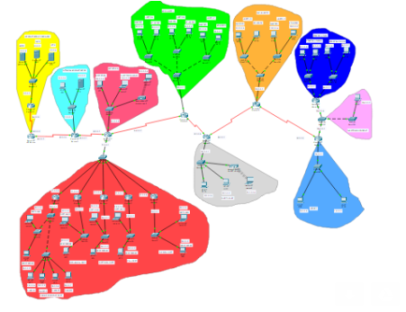

SOFTWARE SIMULATION
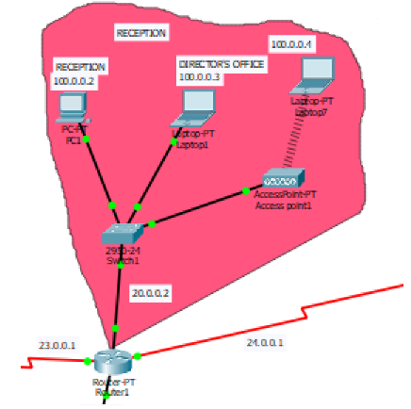
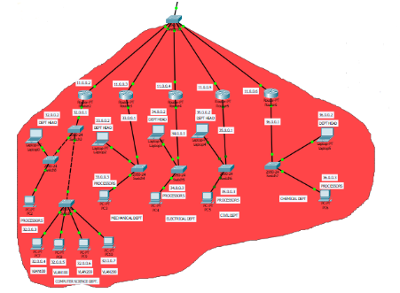

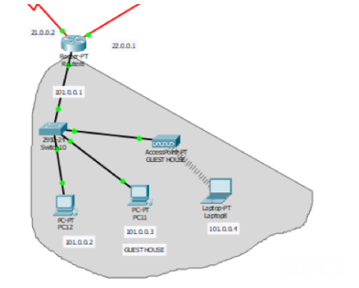

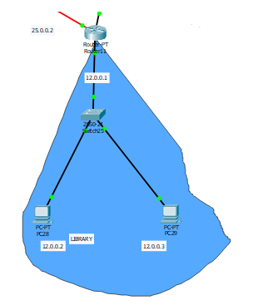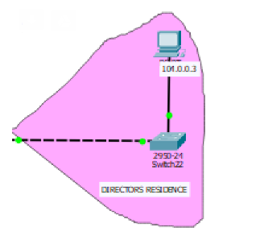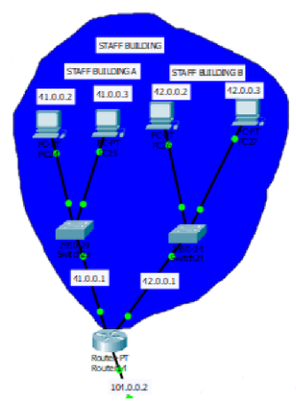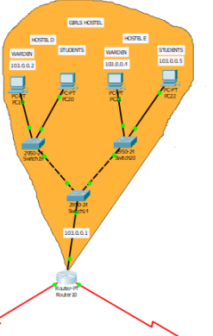
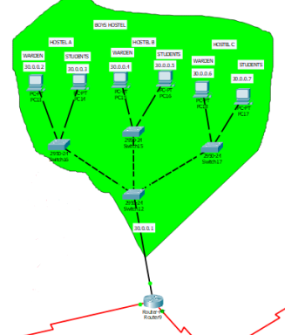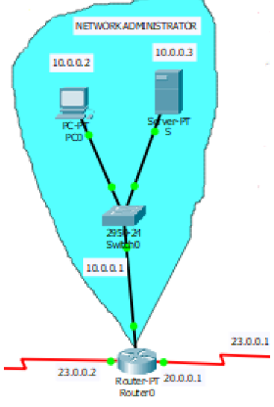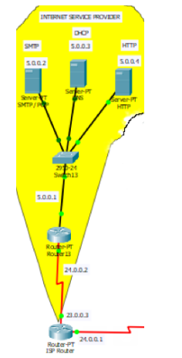
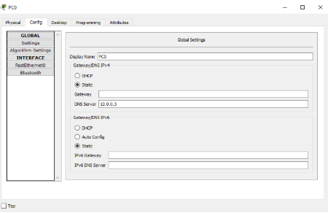

OUTPUT
REAL TIME :
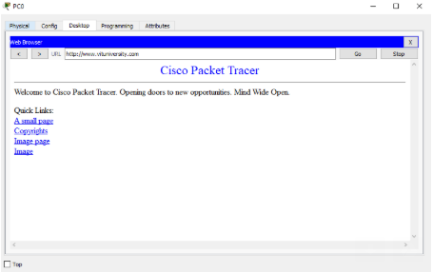
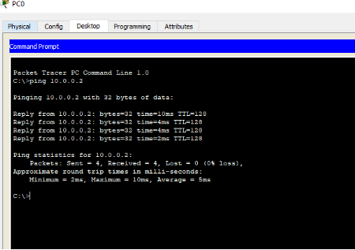

SIMUALTION TIME:
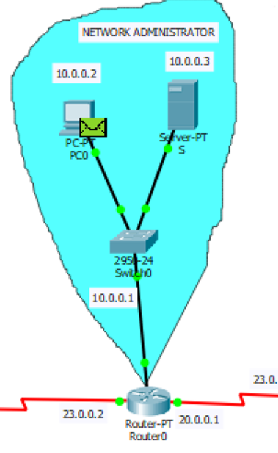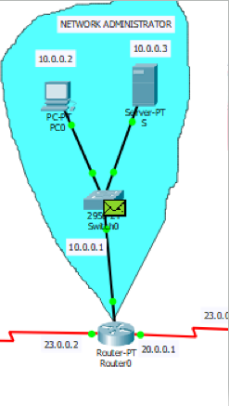
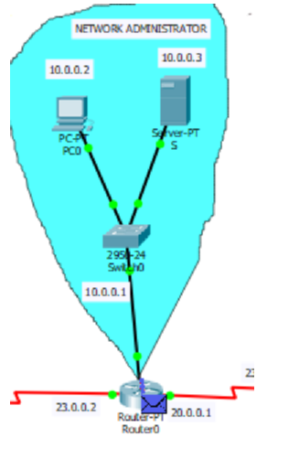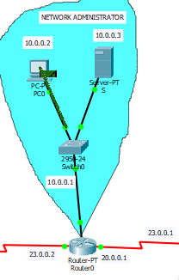
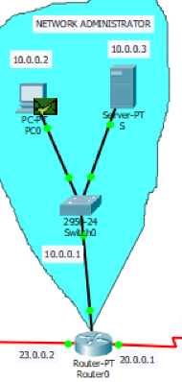

CONCLUSION

Thus we have build the NETWORK DESIGN PROPOSAL FOR UNIVERSITY with the help of cisco packet tracer by implementing the protocols.

FUTURE WORK
We can further implement it using IPV6 protocol and for further increase in protection we can use protocols like firewall,vlan,etc., to ensure the protection and security of the data.
REFERENCES
[1] Comer, Douglas (2000). Internetworking with TCP/IP:Principles,Protocols, and Architectures – 4th ed. Upper Saddle River, NJ:Prentice Hall. p. 394. ISBN 0-13-018380-6.
[2] S. Floyd & V. Jacobson,“The Synchronization of Periodic Routing Messages”, April 1994
[3] “PORT NUMBERS”, The Internet Assigned Numbers Authority (IANA).May 2008
[4] “Network Security Basics”, 7 May 2004 by Robyn Aber
[5] IEEE 802.1Q-2011, 1. Overview
[6] IEEE 802.1Q-2011, 1.4 VLAN aims and benefits
[7] RFC 760, DOD Standard Internet Protocol (January 1980)
[8] Internet Protocol-DARPA Internet Program Protocol Specification. September 1981. p. 7. RFC 791.
[9] "NetAcuity Edge Offers Hyper-local IP targeting"Retrieved 2011- 12-10.
[10] Groth, David; Toby Skandier (2005). Network+ Study Guide, Fourth Edition. Sybex, Inc. ISBN 0-7821-4406-3.
[11] ATIS committee PRQC. "mesh topology". ATIS Telecom Glossary 2007. Alliance for Telecommunications Industry Solutions. Retrieved 2008-10-10.
[12] Chiang, Mung; Yang, Michael (2004). "Towards Network X-ities From a Topological Point of View: Evolvability and Scalability". Proc. 42nd Allerton Conference.

